Email Templates

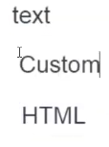

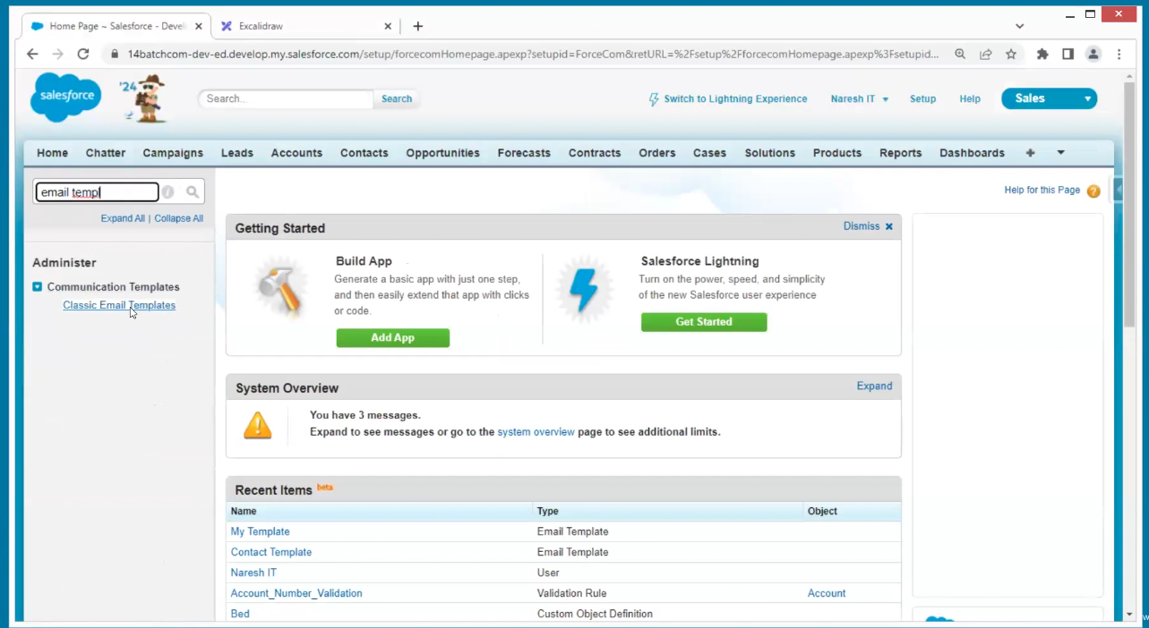

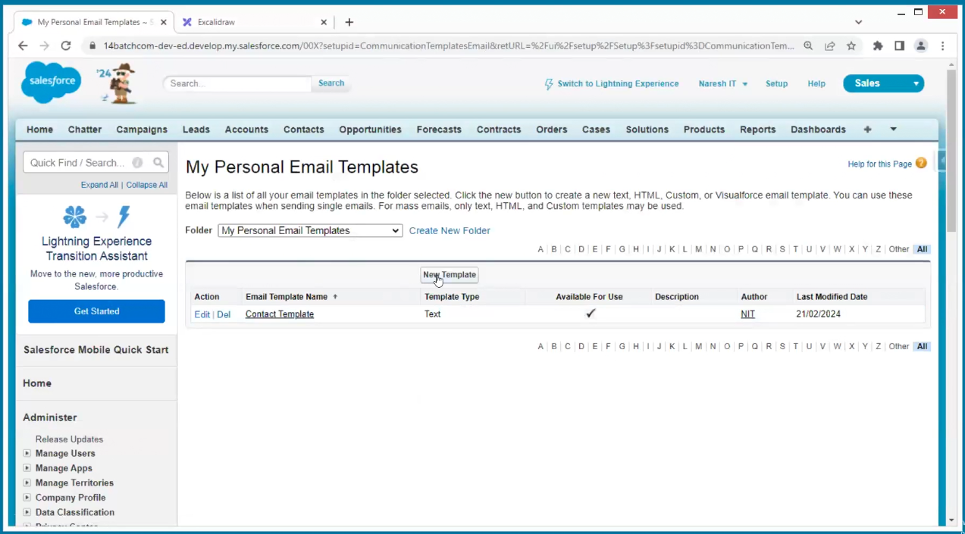

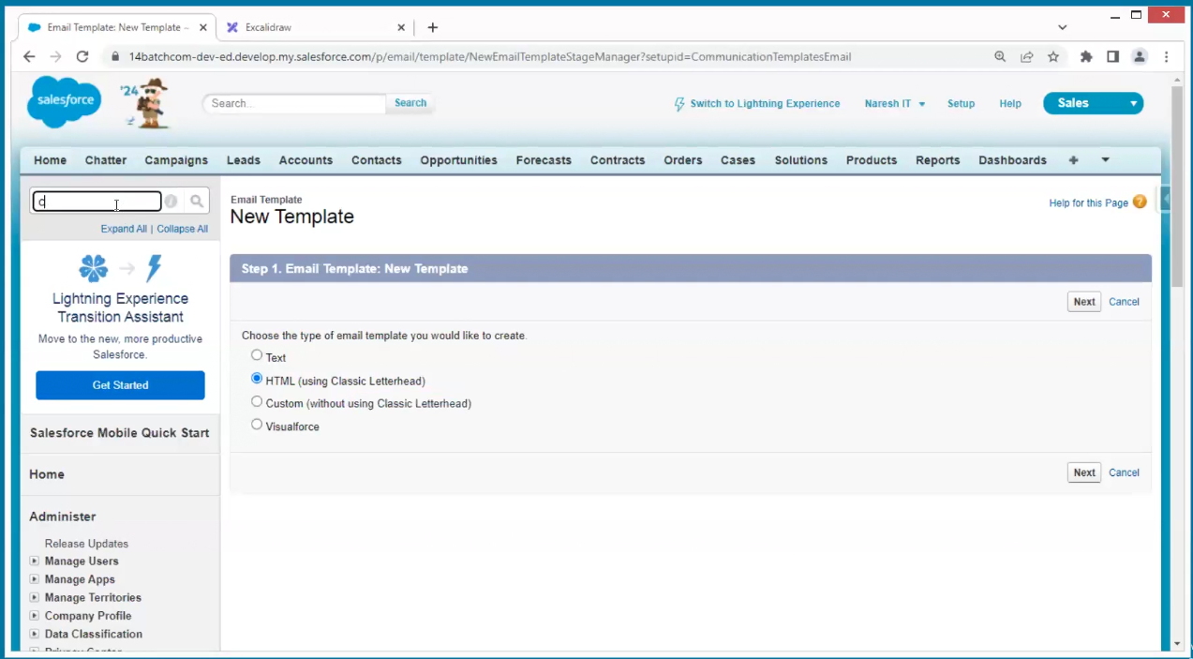

In html sales force created standard letter head

Classic Letterheads

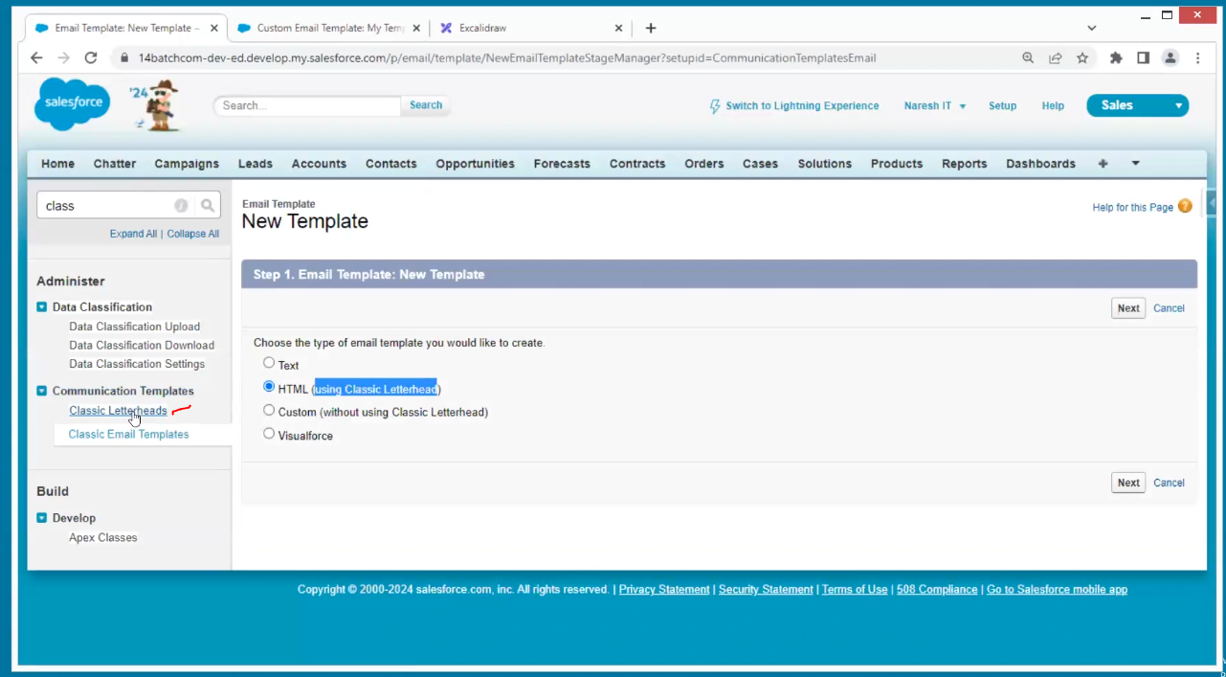

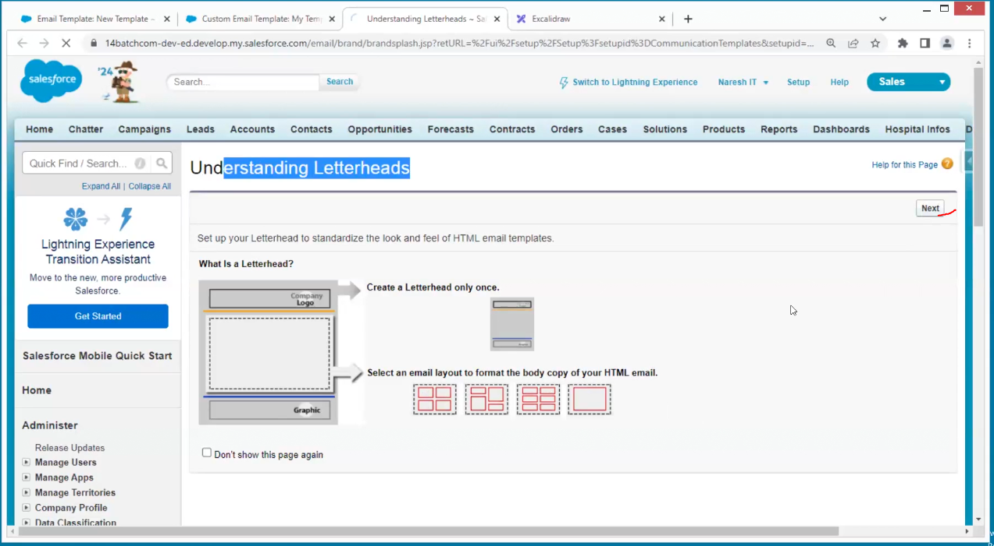

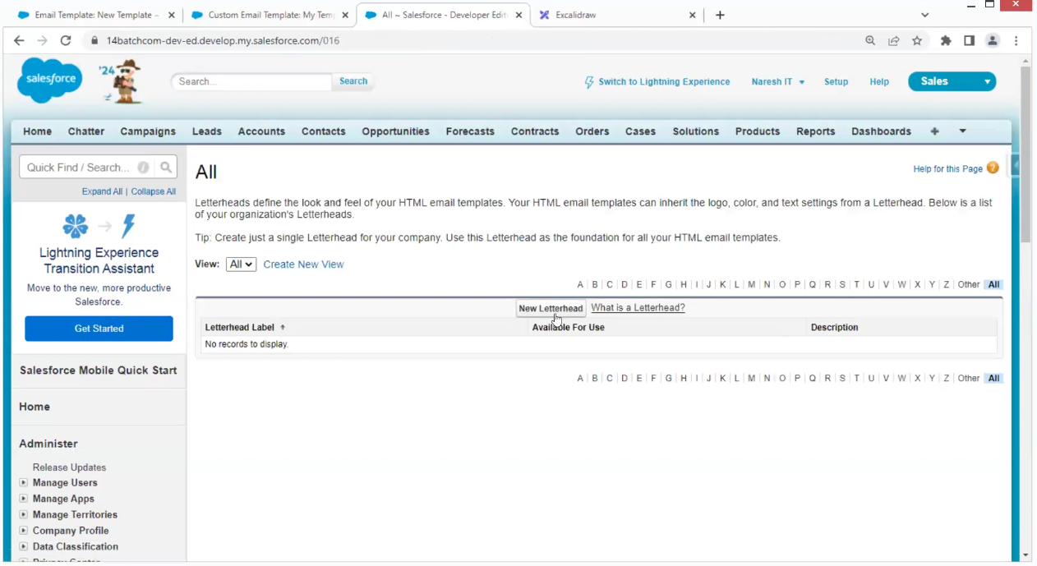

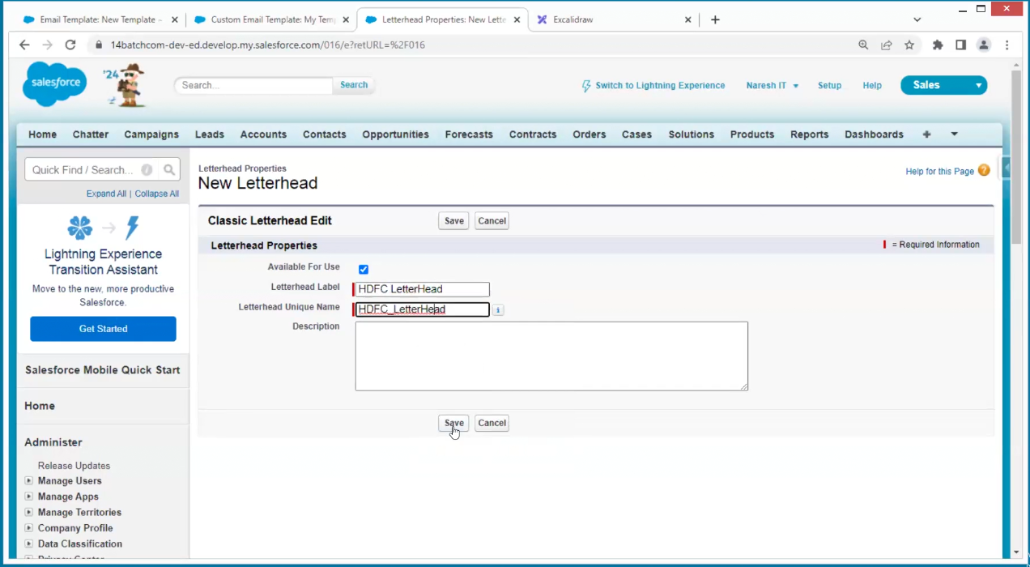

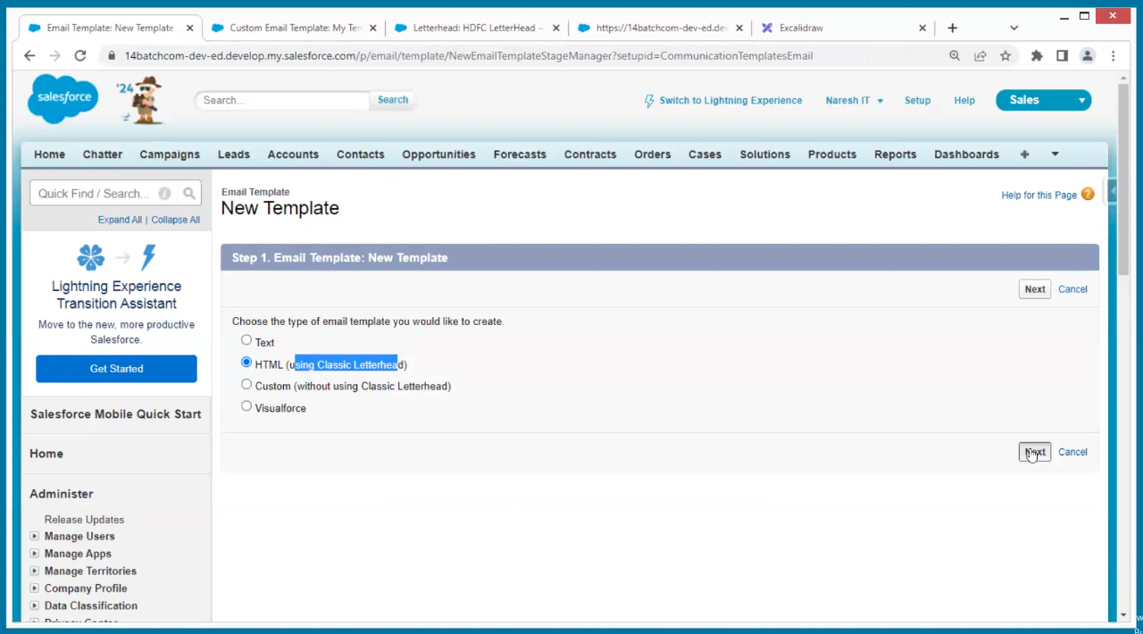

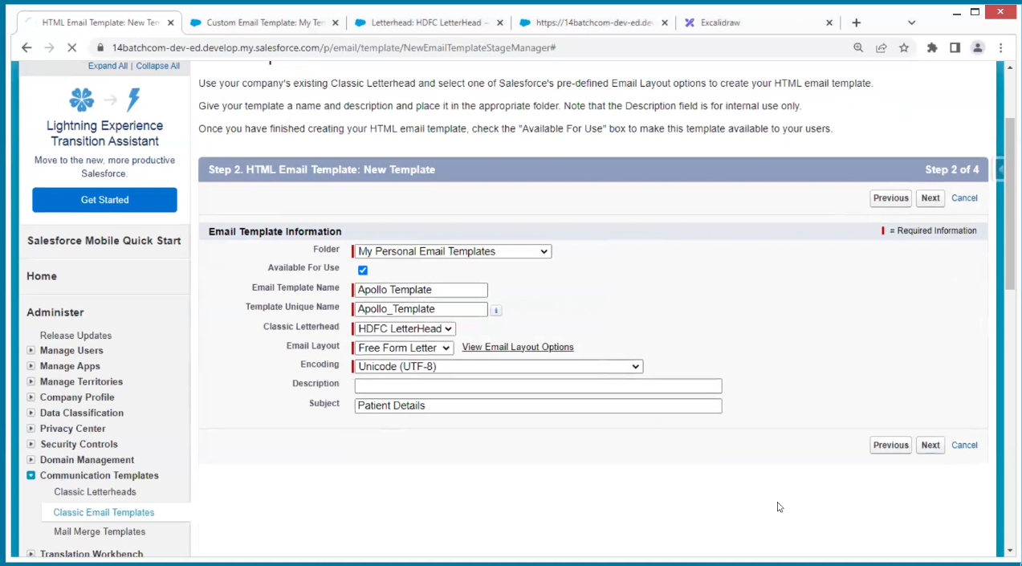

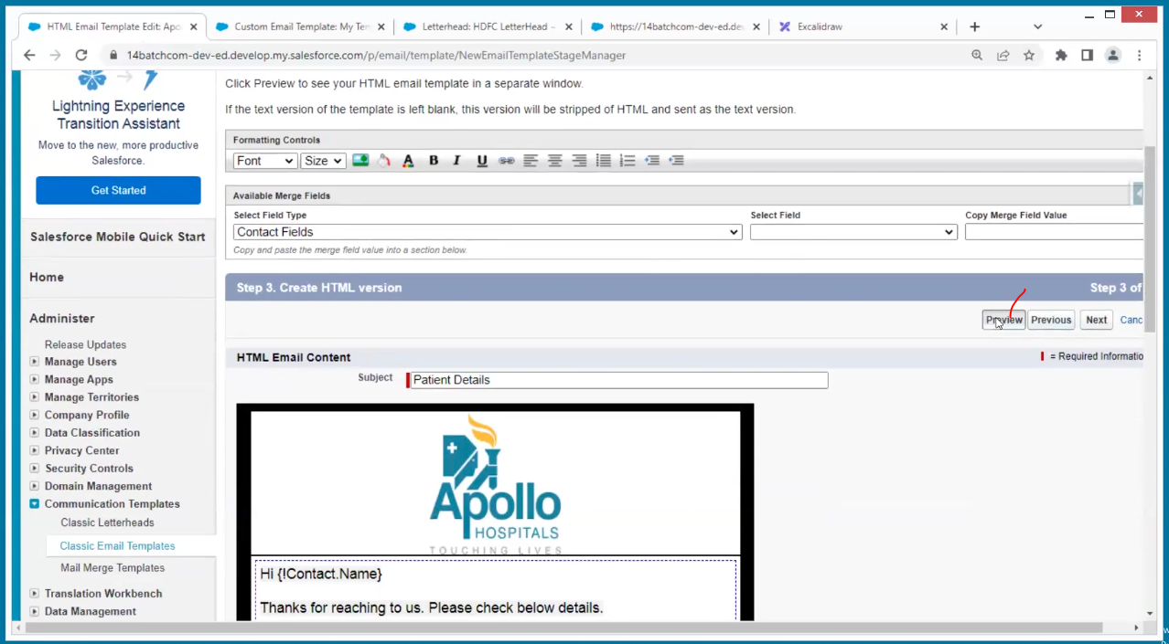

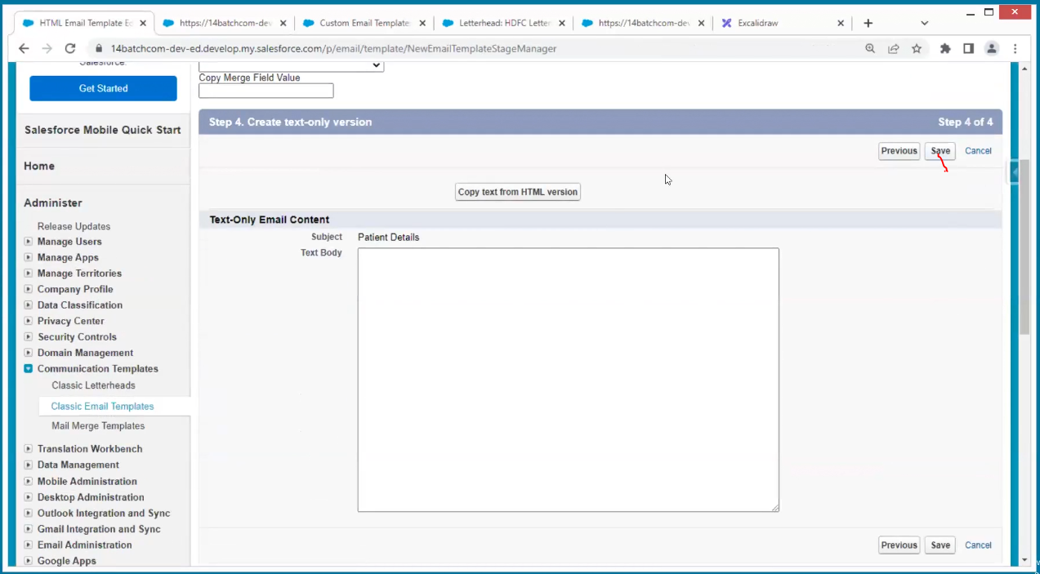

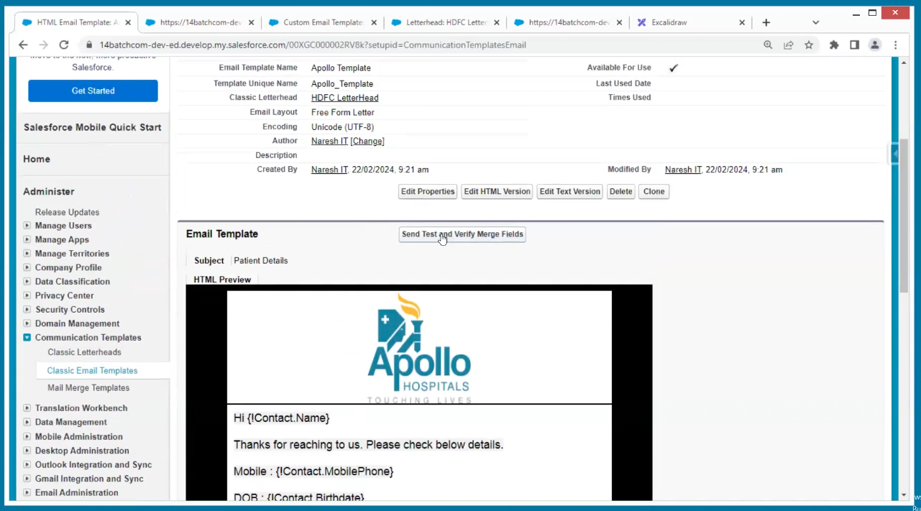

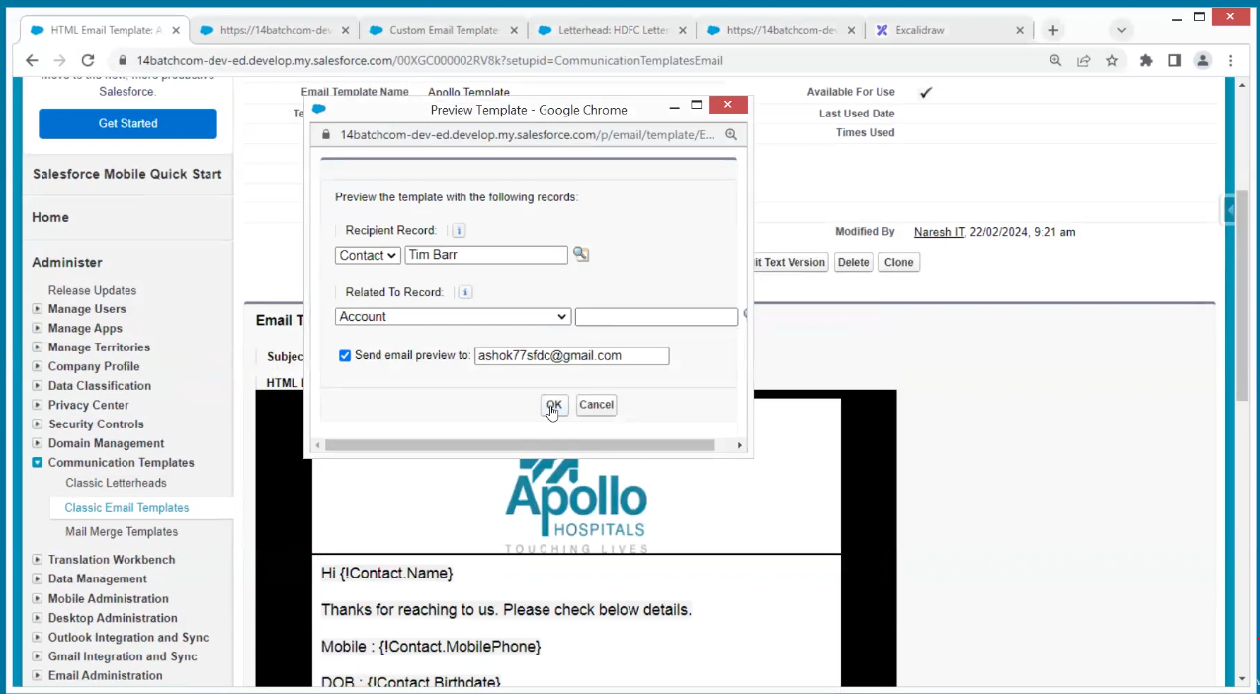

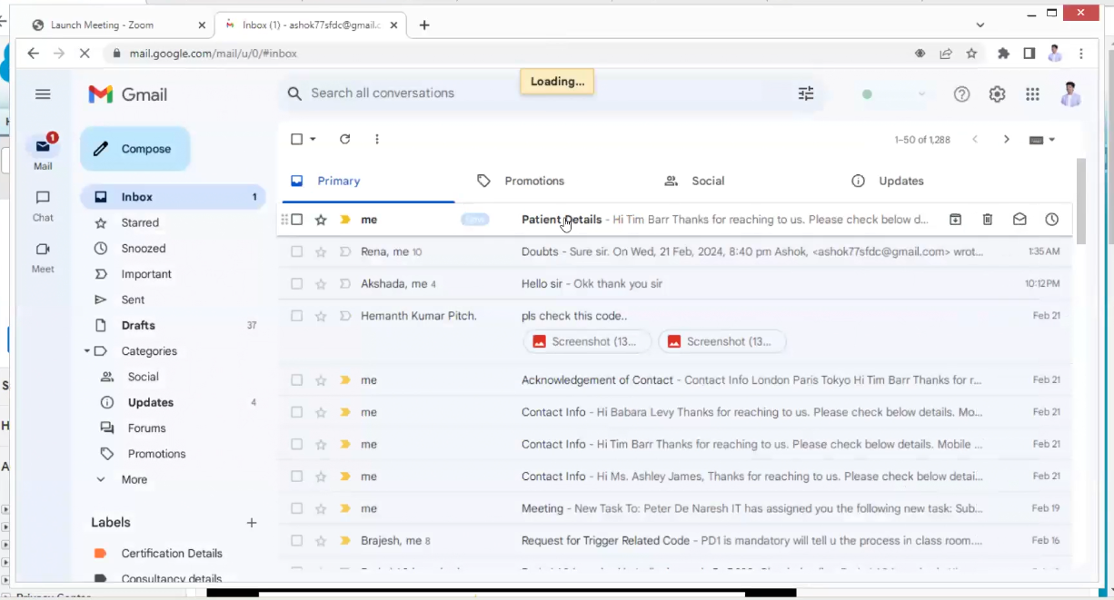

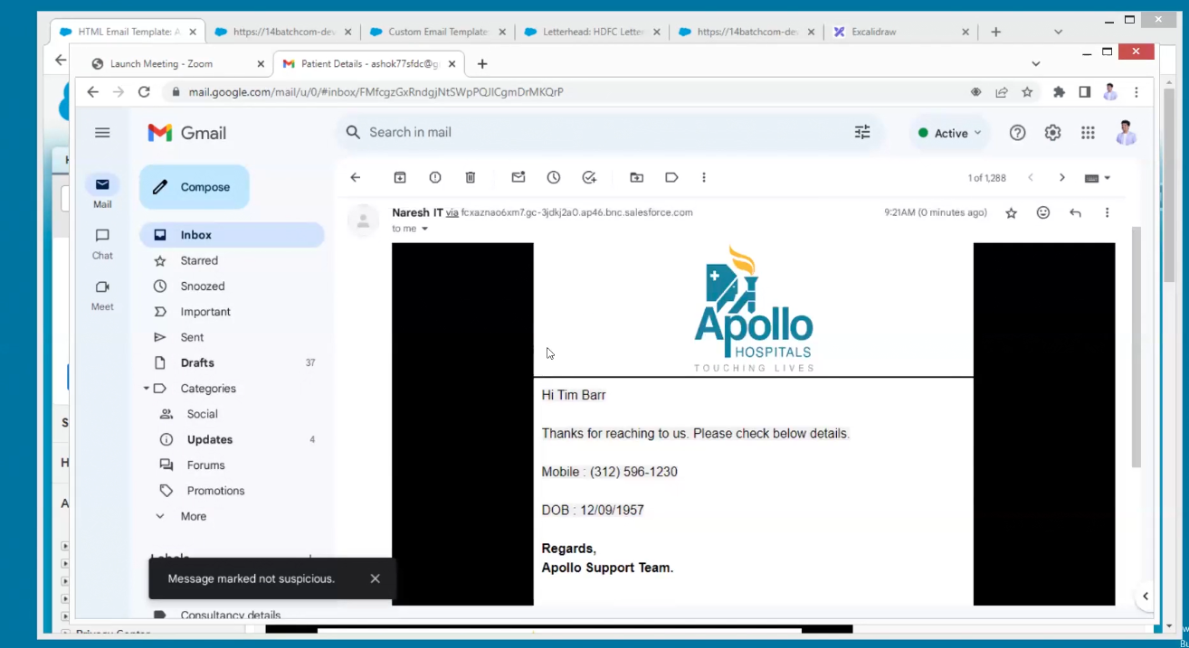

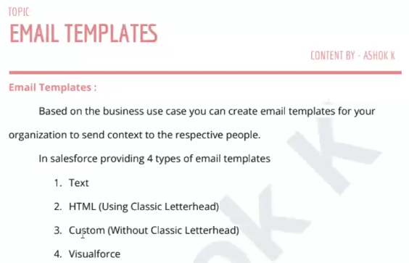

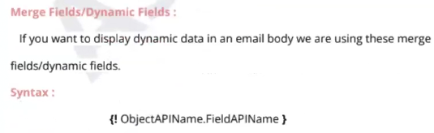

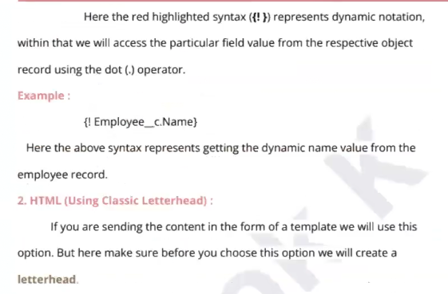

Q) What is the relationship between contact and account

Now apple people are using the salesforce the conducting the campaign’s

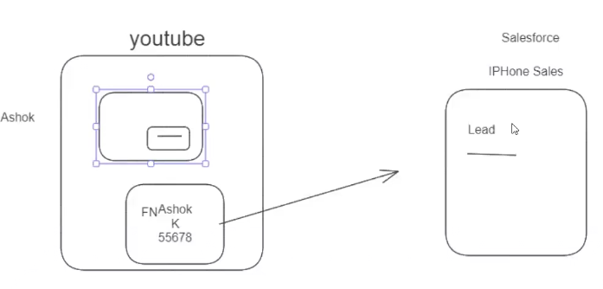

Here YouTube is the source for the lead

From websites how we are capturing the lead data

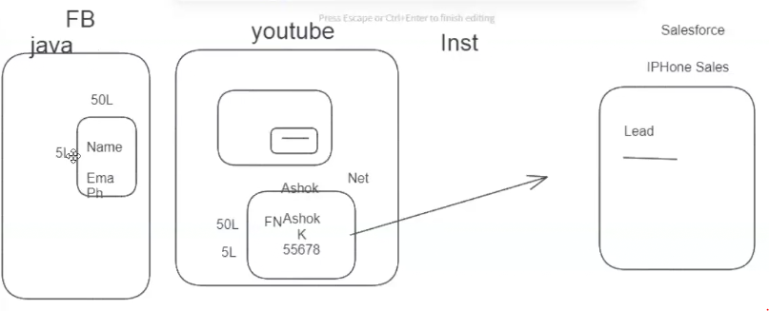

For example, iPhone people want to campaign through sales force they go to social media app and for example Facebook is running through code. The salesforce will tell to provide one page and maintain that page and send that details to me for that I will pay for example creation of page(form) 50L and running the page(form) 5L if we consider more app it will takes lots of money so to avoid this sales force is creation their own form and giving to other apps here CROS (cros domain technology) will occur means they won’t allow sales force page then how?

Our browser knows only HTML +JS

We have an interpreter I between every website and browser

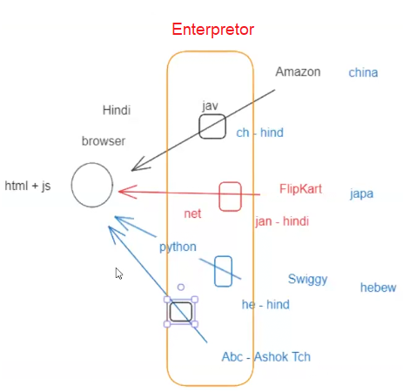

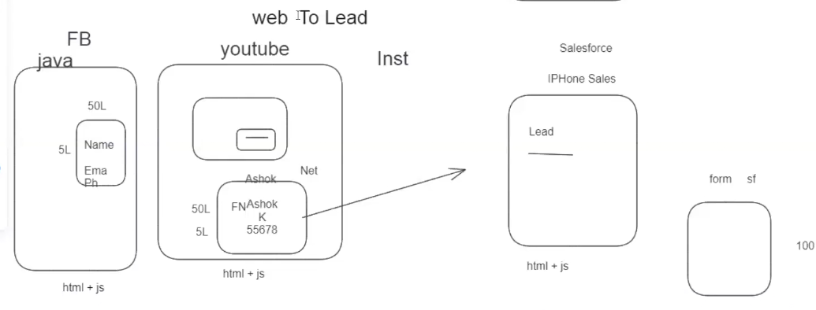

Now the form is created in html and js and linked to all websites on the browser on the browser every this is converted to HTML and JS so both will be same on browser the problem is resolved

Now I am creating one HTML form

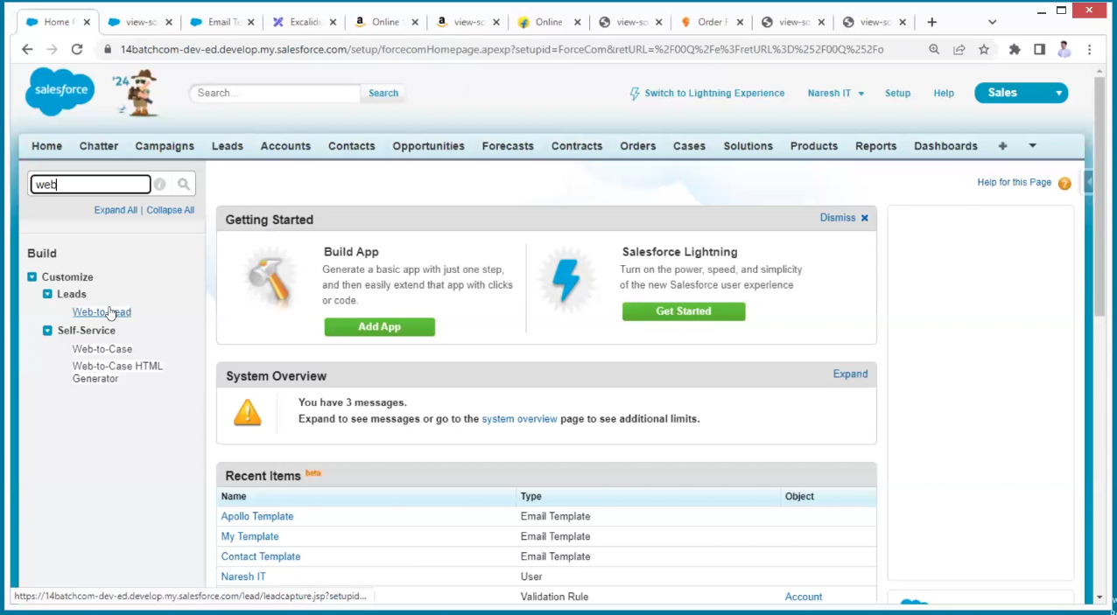

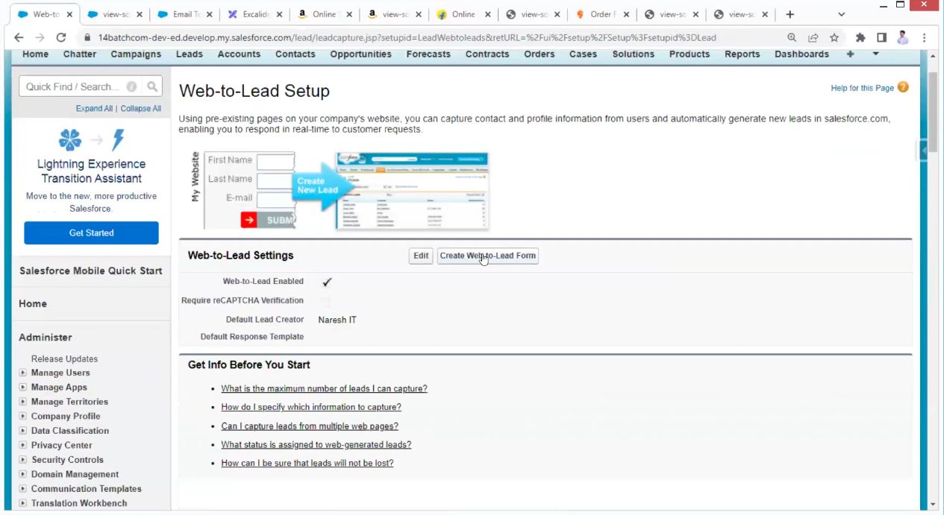

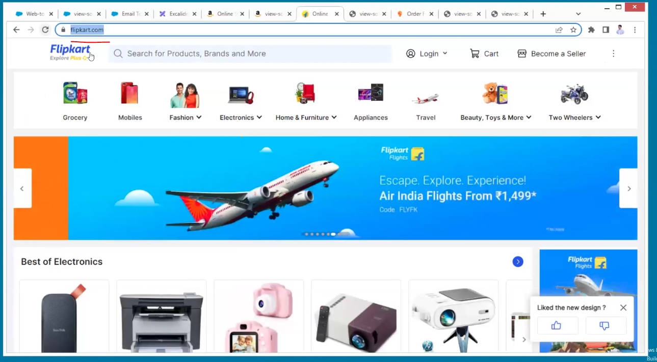

Google people are providing reCAPTCHA

For security reasons, for example we create a code for hitting the server many times then sever down, and hackers can hack the server to avoid that they were providing reCAPTCHA for every request a captcha will change it is not possible to hit the server at a time with many requests

We need to know integration concept to create a captcha here not required.

Web to lead setup

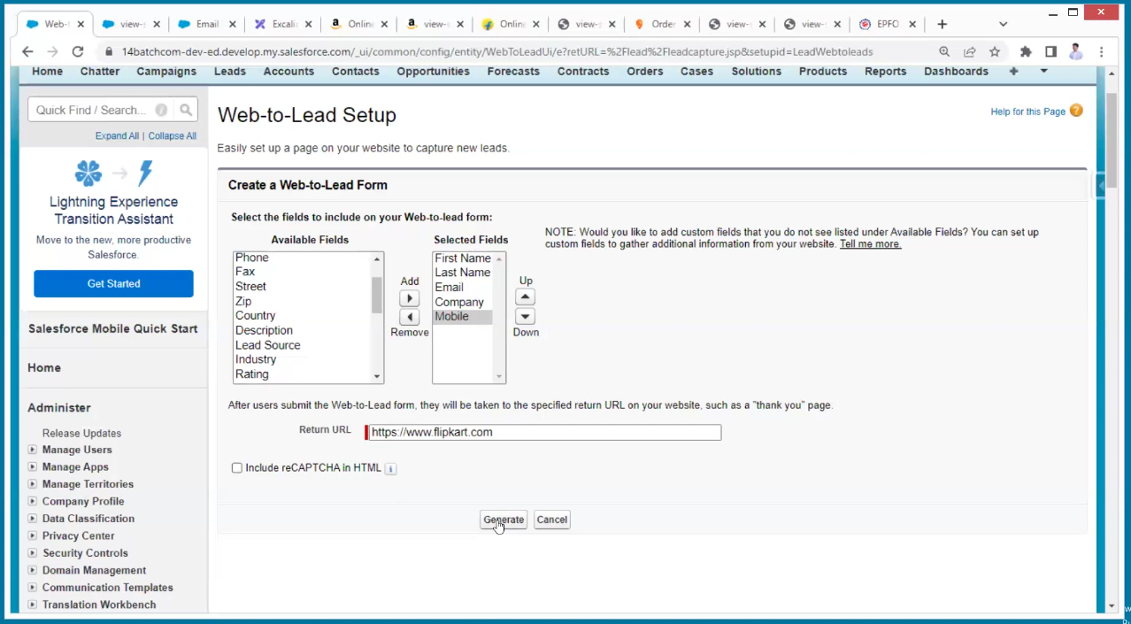

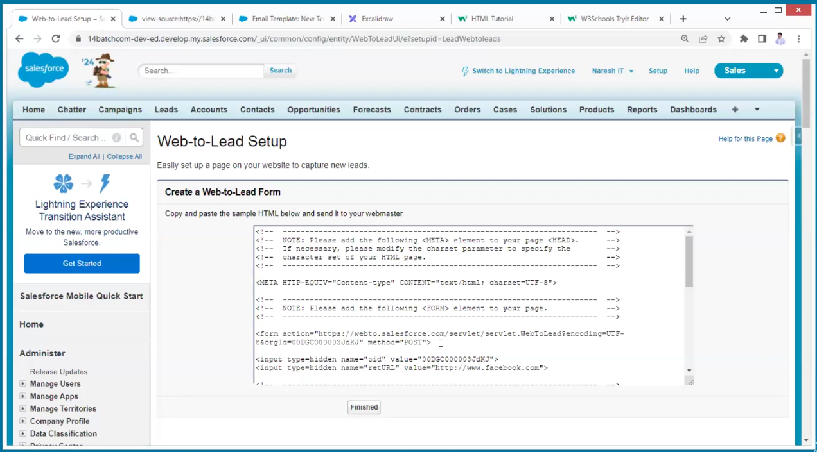

Copy the above code and check in check in the W3 schools

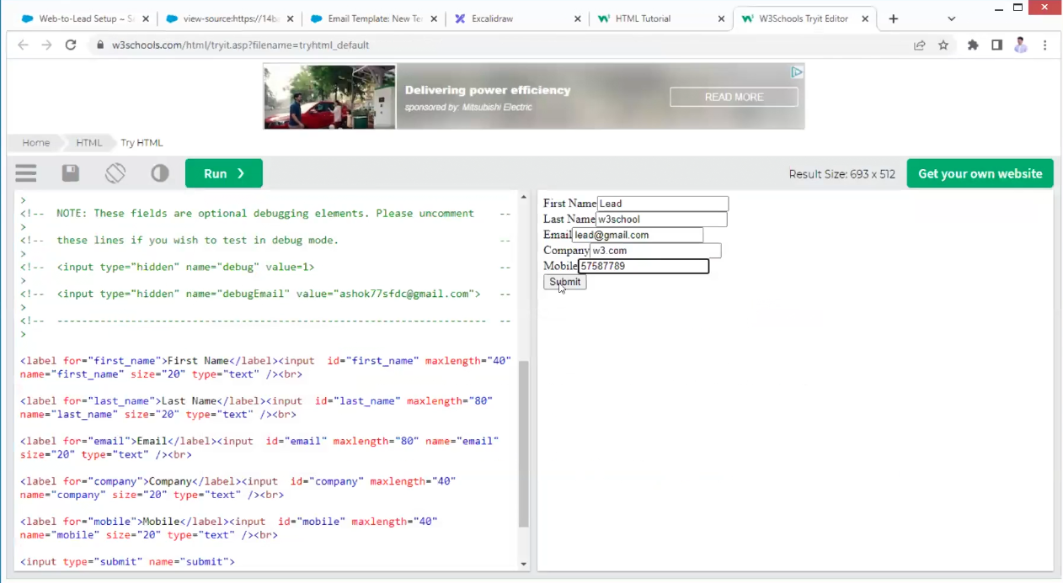

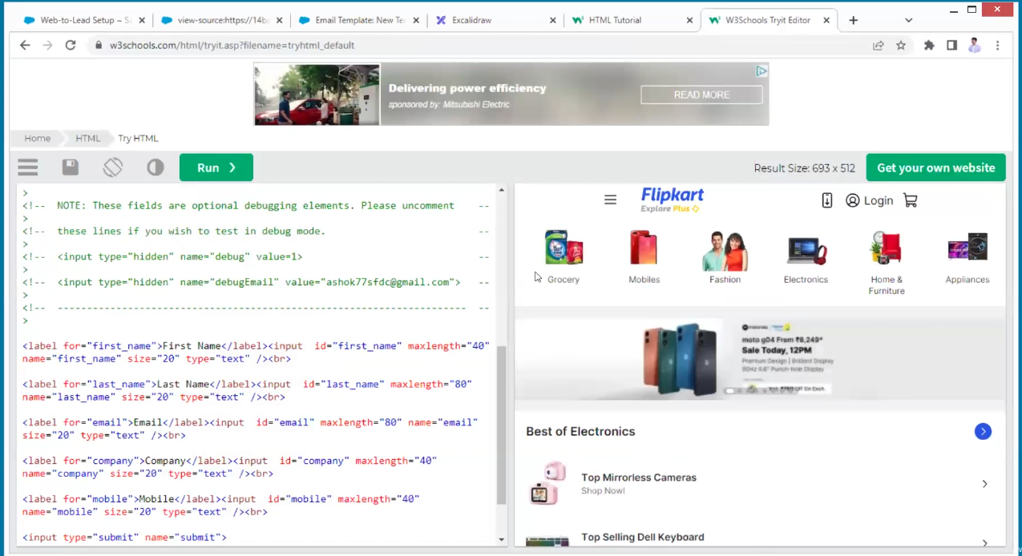

Now we can see this in lead object

